Creation of Azure Key Vault

1.

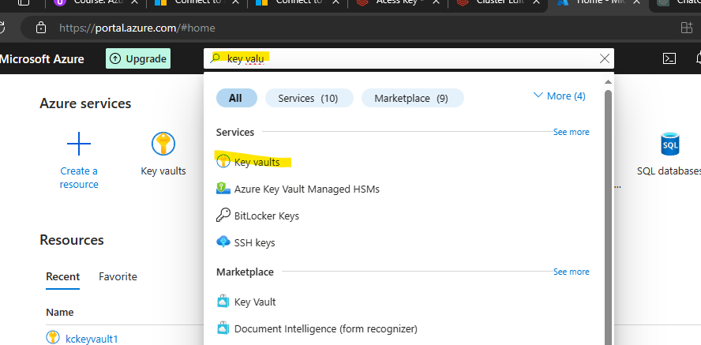

2.

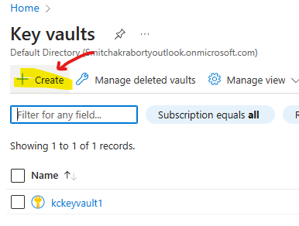

3. Fill the form then go to next

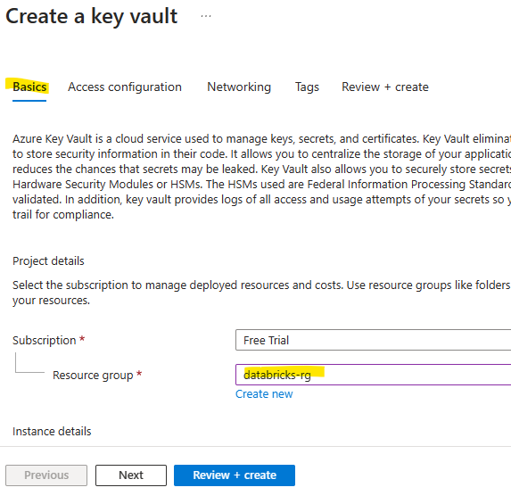

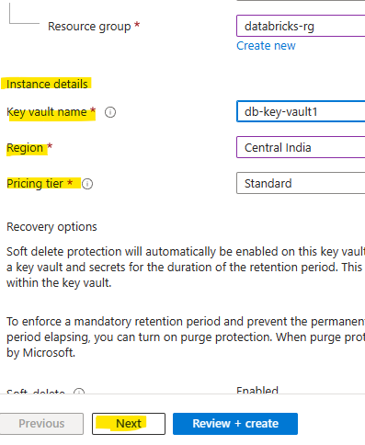

4. Ensure to check Azure role-based access control (recommended)

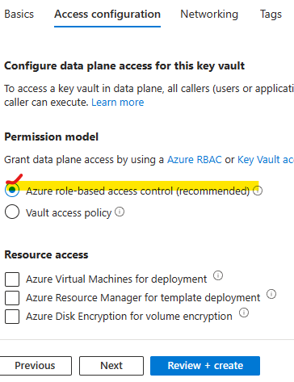

5. In networking we can select all user or selected user after adding the network

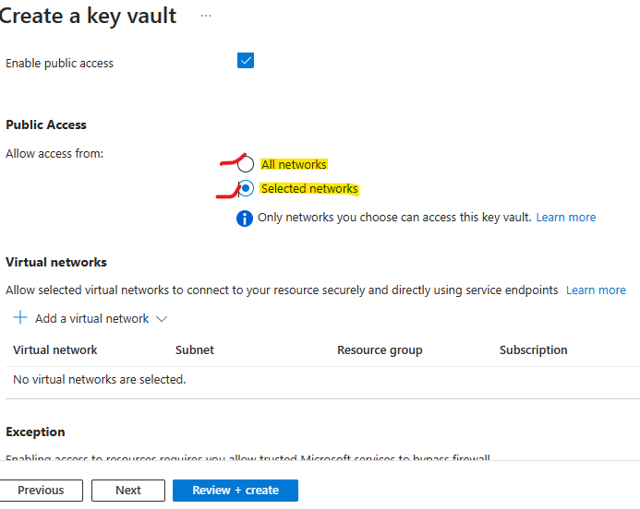

6. Finally Create it

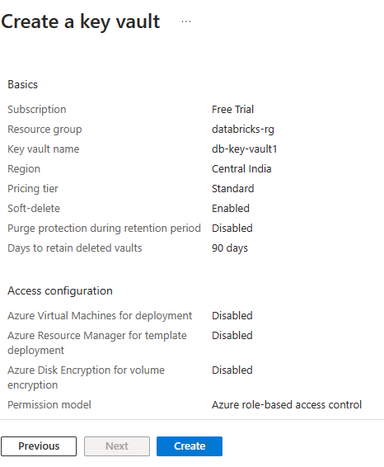

How to add secrete?

1. Go the created Key Vault 🡪 Secret 🡪Generate/Import

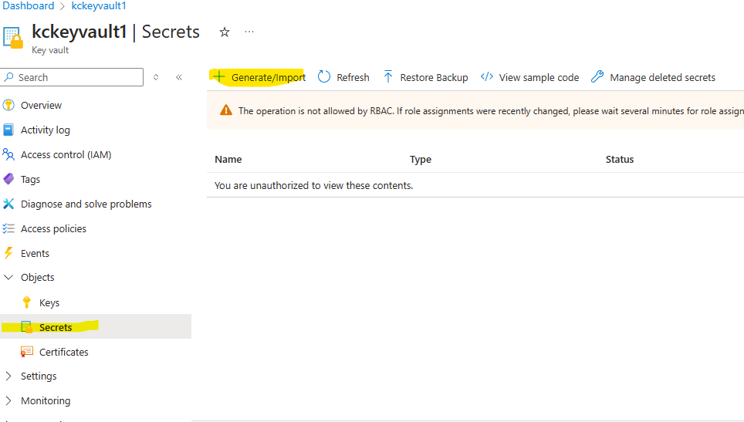

1. Copy the access key and paste it in secret value, give name and make sure it is enable, we can set expiry date

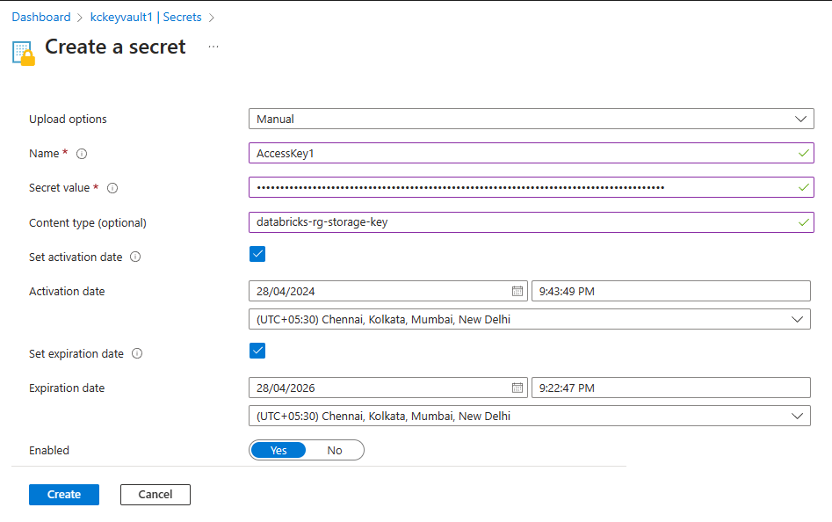

1. We can see the key here

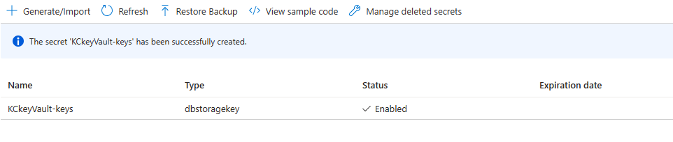

1. If there problem comes in key creation add the IAM permission

Key Vault Administrator: Perform all data plane operations on a key vault and all objects in it, including certificates, keys, …………………….

Now we need to create the Dadabricks backed secret scope for that go to

<https://adb-4500051995277724.4.azuredatabricks.net/?o=4500051995277724#secrets/createScope>

<https://adb-4500051995277724.4.azuredatabricks.net/?o=4500051995277724>

after this add #secrets/createScope

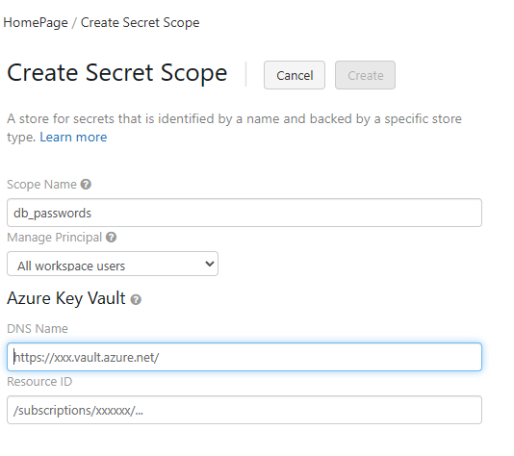

1. Then open the key vault

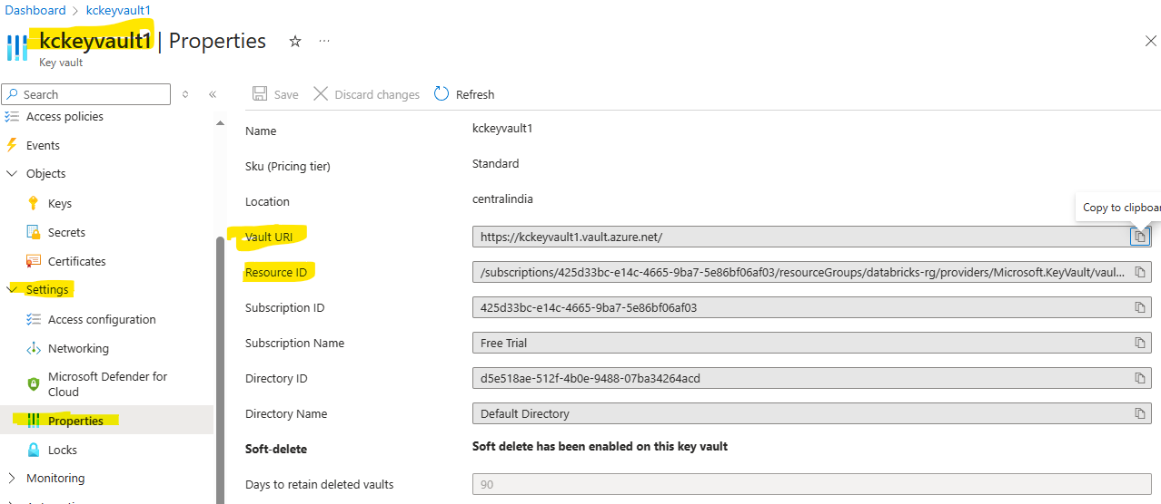

And paste value url of keyvault properties to DSN name and resource id to resource id

